

BCA Volunteer Advocates provide valuable support to vulnerable people in their community.

Many people are vulnerable through age, disability or isolation. Our volunteers are trained and supported to speak up for people and make sure their voice is heard and that they are part of their local community.

For anyone who wants to make the commitment to become an advocate it is extremely rewarding and worthwhile. You have the satisfaction of knowing that what you are doing makes an important difference to someone’s life. We offer a variety of volunteering roles working with vulnerable people of different ages and abilities.

As a Volunteer you will attend training (4 days in total) which will give you the information you need to take on the role of Volunteer Advocate. During and after training you will get the opportunity to discuss your views and the type of advocacy you feel most suited to undertake. This might be a regular commitment visiting someone or it might be a ‘one-off’ issue that you help the person resolve.

Advocates have supported people to
- say where they want to live
- get the support they need to help them live as independently as possible
- join in a local volunteer group
- make plans for the future
- feel included in their local community
- obtain their rights
- complain about unfair treatment
- feel less isolated and vulnerable

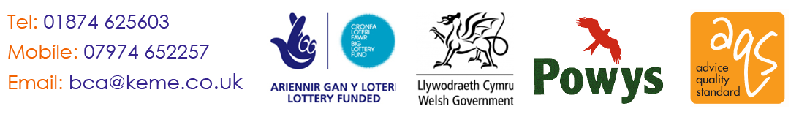

As a Volunteer Advocate you can rely on on-going support and help from BCA staff. Because you work one to one with vulnerable people you will be asked to undergo an enhanced criminal record bureau check

John is one of our volunteer advocates, this is what he has to say about his role:

“I wanted to do something that made a difference. I don’t have any special skills but I am a good listener and I get on well with people.

I wasn’t sure what to expect when I first heard about volunteer advocacy — it sounded very formal but it wasn’t like that at all. BCA made me really welcome and gave me training about what it means to be an advocate supporting a person with a learning disability to make choices and say what they would like from life.
I’ve supported Jim for four years and we get on well. He trusts me and talks a lot of things over with me. He says this really helps him. He never used to say what he wanted because he was sure no one would listen - now he makes suggestions about all sorts of things, like doing a college course to help him read and write better”

Jean is Jim’s mother, she says

“Jim lives in supported accommodation. When it was suggested he would benefit from having an advocate I really wasn’t sure how having a volunteer with no special skills would help Jim. Now I know, I’ve seen Jim get more self-confident and John is someone special in his life. I wish everyone like Jim could have an advocate.”

Names have been changed to protect confidentiality

Because of the type of work we undertake, regretfully, we cannot accept anyone under 18 as a Volunteer Advocate

