Correspondence and Registered office address 11 Lion Yard, Brecon, Powys, LD3 7BA Reg. Charity No.: 1123605 Reg. Co. No.: 06509168
CEO: Elizabeth Roderick Patron: Kirsty Williams AM.

BCA Referral Form

MAKING A REFERRAL TO BCA

Please use the form on this page to make a referral to any of our advocacy services.

If you are not sure whether a referral is appropriate, or you want further information please call us on 01874 625 603.

Name:
Address:

Postcode:
Phone:
Date of Birth:
Your Name:
Organisation:
Your Address:

Postcode:
Your Phone:
Your Email:
Reason for Referral:

Date:

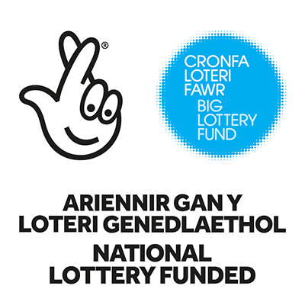




Tel: 01874 625603



Mobile: 07974 652257
Email: bca@keme.co.uk

